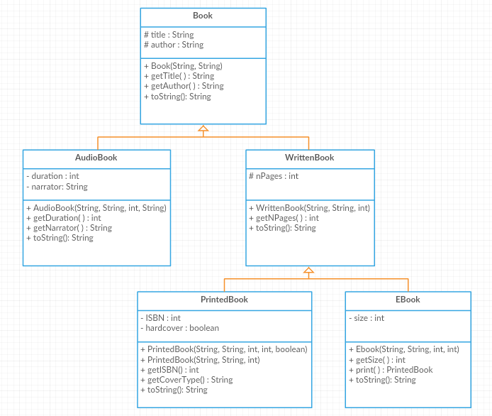

**Book class:**

Attributes:

* title: the title of the book
* author: the author of the book

Methods:

* Book(title: String, author: int): constructor
* getTitle(): this method returns the title of the book
* getAuthor(): this method returns the author of the book
* toString(): returns the object’s info in this format: ‘Title: *title*, Author: *author*’

**AudioBook class**:

Attributes:

* duration: the length of the audio file in minutes
* narrator: the name of the person reading the book

Methods:

* AudioBook(title: String, author: String, duration: int, narrator: String): constructor
* getDuration(): this method returns the duration of the audio book
* getNarrator(): this method returns the name of the narrator
* toString(): returns the object’s info in this format: ‘Title: *title*, Author: *author,* Format: Audio, Duration: *duration,* Narrator: *narrator*’

**WrittenBook class:**

Attributes:

* nPages: the number of pages of the book

Methods:

* WrittenBook(title: String, author: String, nPages: int): constructor
* getNPages (): this method returns the number of pages of the book
* toString(): returns the object’s info in this format: ‘Title: *title*, Author: *author,* Format: Written, number of pages: *nPages*’

**PrintedBook class:**

Attributes:

* ISBN: the International Standard Book Number of the book
* hardcover: true if the book is hardcover, false otherwise

Methods:

* PrintedBook(title: String, author: String, nPages: int, ISBN: int, hardcover: boolean): constructor
* PrintedBook(title: String, author:String, nPages: int): constructor that initializes ISBN to 0 and hardcover to false
* getISBN(): this method returns the ISBN of the book
* getCoverType(): returns a string specifying if the book is hardcover or paperback
* toString(): returns the object’s info in this format: ‘Title: *title*, Author: *author,* Format: Written, number of pages: *nPages,* Printed, ISBN: *ISBN,* hardcover/paperback’

**EBook class:**

Attributes:

* size: the size of the ebook in MBs

Methods:

* EBook(title: String, author: String, nPages: int, size: int): constructor
* getSize(): this method returns the size of the ebook
* print(): this method returns the current Ebook as an object of type PrintedBook
* toString(): returns the object’s info in this format: ‘Title: *title*, Author: *author,* Format: Written, number of pages: *nPages,* Ebook, size: *sizeMB*’

Exercise: Translate into Java-code the previous classes.